**System Proposal Document**

**For**

**New Century Wellness Group**

**New Business and Health Information management system**

**By**

**Priyanka Bhumi Reddy**

**Introduction:**

New CenturyWellness group is an organization of Timothy Jones and Dolores Gracias who combined their individual practices 10 years ago (Rosenblatt, 2014).

This group has physicians, nurse practitioner, physical therapists, nutritionist and support staff serving 8000 patients from 325 employers accepting 25 insurance companies.



**Background:**

As per the business proposal a system is designed in a way to operate the current operations like scheduling the appointments, billing and accounting. It also stores all the data regarding patients records to financial data like bills and accounts. This project concentrates on the general audience, workers and clients (Rosenblatt, 2014).

Business process starts from appointment to collection of bills

**Patient🡪makes an appointment🡪visits any health provider🡪records the details on EMR🡪checks whether records completed🡪billing🡪collects the bills (accounting)**



**Problem:**

**Requirement:** It requires a business and information management system to operate the present clinical operations and future growth.

**Why it needs?**

* It needs an information system to replace the paper based process and fragmented computers.
* It requires to provide efficient service to the patients. Since if patients record exchanges then there will be a huge impact on them and their lives.
* Financial matters are also the key role in managing the Health Centre. So fast financial process helps them to invest and expand their future business.

**Impacts:**

* There are lot of impacts on the business if they don’t update their information system.
* There is a lot competition from competitors, there may be a chance of losing business income by slow process.
* Unnecessary human power is utilized to do small jobs.
* Weak management system may lead to lots of mistakes regarding patients records and details.

**Audience:**

Who doesn’t have any knowledge on technology like managers, medical professionals, Administrative department, Financial department are the crucial and very important people. Communication between departments is the main criteria. So there will be levels of management decided between departments.

**High level management**:

Medical professionals like physicians, therapists, specialists needed the information system to analyze their work and the work needed to be stored for future analysis and educating the future medical professionals.

**Second level management:**

Nurses, operators need the information system to update their work to the medical professionals. This level of management communication is most important to both high level and low level departments

**Low level or End Level Management:**

Basically the financial departments like billing section and accounting sections are considered as end level managements. These sections communicate with the end clients like Employers and Insurance companies to collect the bills. This level describes the financial distributions among the other departments

**SYSTEM REQUIREMENTS**

**Requirements Modelling**

The New Century Wellness Group is as of now utilizing is obsolete as well as not working for the staff. It is a blend of paper-based and legacy frameworks that depends altogether a lot on the staff for exactness and consummation. New Century staff incorporates four essential care doctors, one medical attendant professional, four physical specialists, one enlisted nutritionist, eight attendants and eight staff individuals tending to a patient base of 8,000 from 325 unique managers who cover representatives' wellbeing and support. New Century as of now acknowledges 25 distinctive medical coverage suppliers. On top of this, they are wanting to open another branch. Every staff part is in charge of various parts of how the business is run and there is a lot of space for mistake. Along these same lines the present staff will need to begin putting in additional time and they should contract no less than one more staff part (Rosenblatt, 2014).

In building a JAD group for the improvement of this framework, I would incorporate the greater part of the general population who are named in the authoritative diagram above. Specialist Jones and Garcia should be there in light of the fact that they run the center and ought to have the last say in regards to how something functions, and in light of the fact that it would be useful for them to hear how things really function right now. I can envision that they may not generally know the littler points of interest that go into how everything functions since they are caught up with dealing with the greater operations. I would have Anita in participation since she deals with the workplace staff who might be in charge of a large portion of the correspondences with patients (planning arrangements, booking labs, and so on.). Susan, who oversees persistent records, ought to likewise be there so she could give her contribution on what data is required by receptionists, medical caretakers, and specialists at the season of arrangement booking and visits. Tom, who oversees records of sales, ought to take care of give more data on what he requirements to oversee precise charging. Tammy oversees protection guarantees, and ought to be there to give more data on what she needs from Tom and Susan to finish an Insurance guarantee. Lisa, as the Arrangement Manager, ought to be there to discuss the data she manages and how it influences whatever is left of the center. Carla, who oversees supplies, ought to be there so we can ensure the framework gives her the stock data she needs when she needs it.

I did exclude Fred or Corinne on the grounds that they would require a more specific framework that would be able to get to a portion of the framework being arranged previously. Both Fred and Corinne work more with representatives as opposed to Patients and I would meet with them independently.

**System Input**

* Patients' own data: name, address, telephone number, birth date, protection data, conjugal status, and so on.
* Patient history: solutions, past surgeries, lab comes about, and so forth.
* Arrangement times
* Worker data: name, contact data, title, pay, work plan

**System Output**

* Charging/protection claims: patient's methodology at the time visit sent to their insurance agency with comparing charging codes.
* Solutions, orders for lab testing, referrals to other therapeutic suppliers
* Supply orders
* Every day supplier arrangement records
* Worker paychecks and advantages

**System Process**

* Every patient's techniques are legitimately coded for precise charging and follow up systems.
* Medication and patient medicinal data are cross referenced to minimize negative medication collaborations or covering care
* In the event that there is a contention between patient history and new therapeutic requests the framework will instantly caution the supplier by means of a message on the screen
* Understanding arrangements went into timetable, and every day arrangement records are created

**System performance**

* System ought to be completely utilitarian amid business hours and any hours of operation
* System exchanges ought to be quick and smooth

**System control**

* Every staff part ought to have remarkable login accreditations with changing layers of access; for instance, ought not have the same level of access to patient records as suppliers
* Every staff part's get to and capacities ought to relate to their duties

**Data process model**

The following models shown below are the data process models for the new system. The data process model presented here are EMR process, Business solution system, Human resources module, Classical design support system.

**EMR Process**

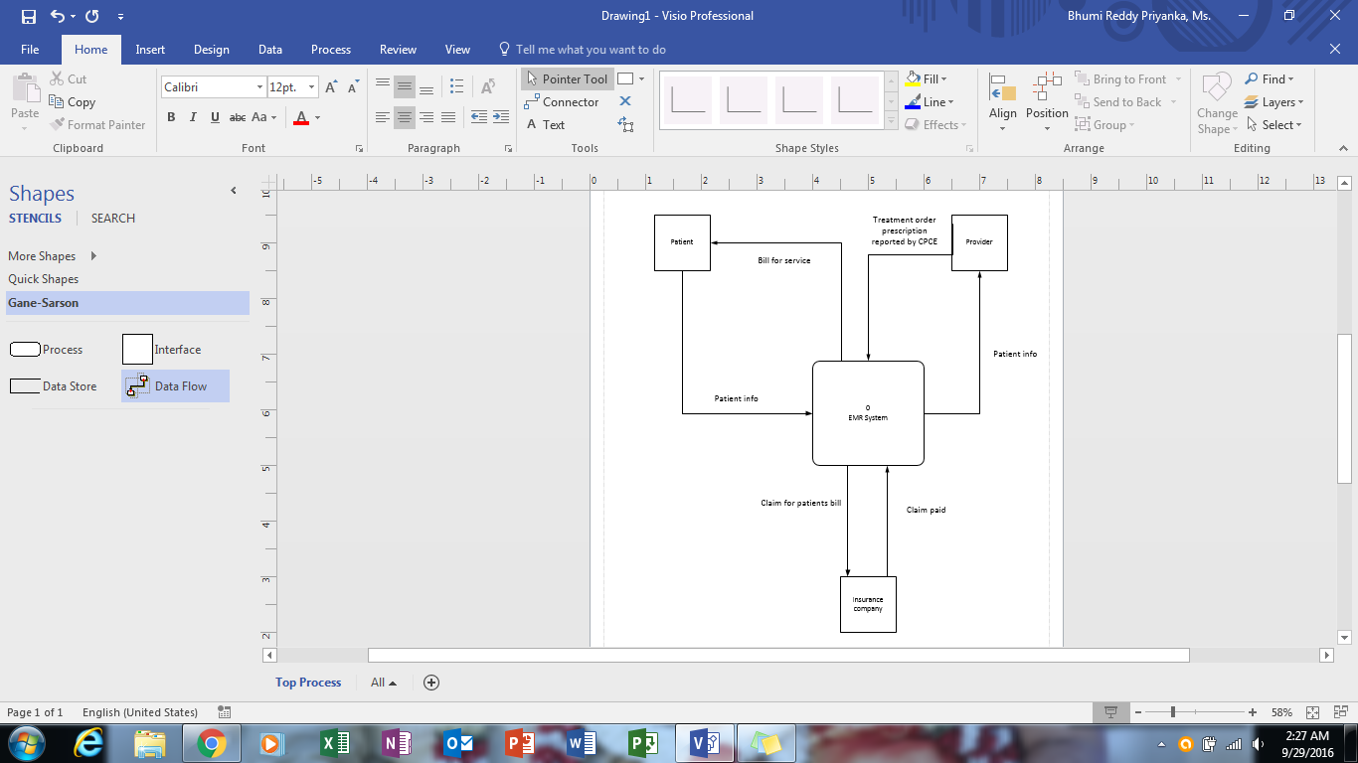

Here EMR system is the process here and all the patient information is stored in this process. The doctor prescription and report of patient is stored in this EMR process. So once the treatment is done the bill is sent to patient’s insurance company for claiming bill. And once EMR gets approval from insurance company, the bill is sent to patient.

**Business Solution System**

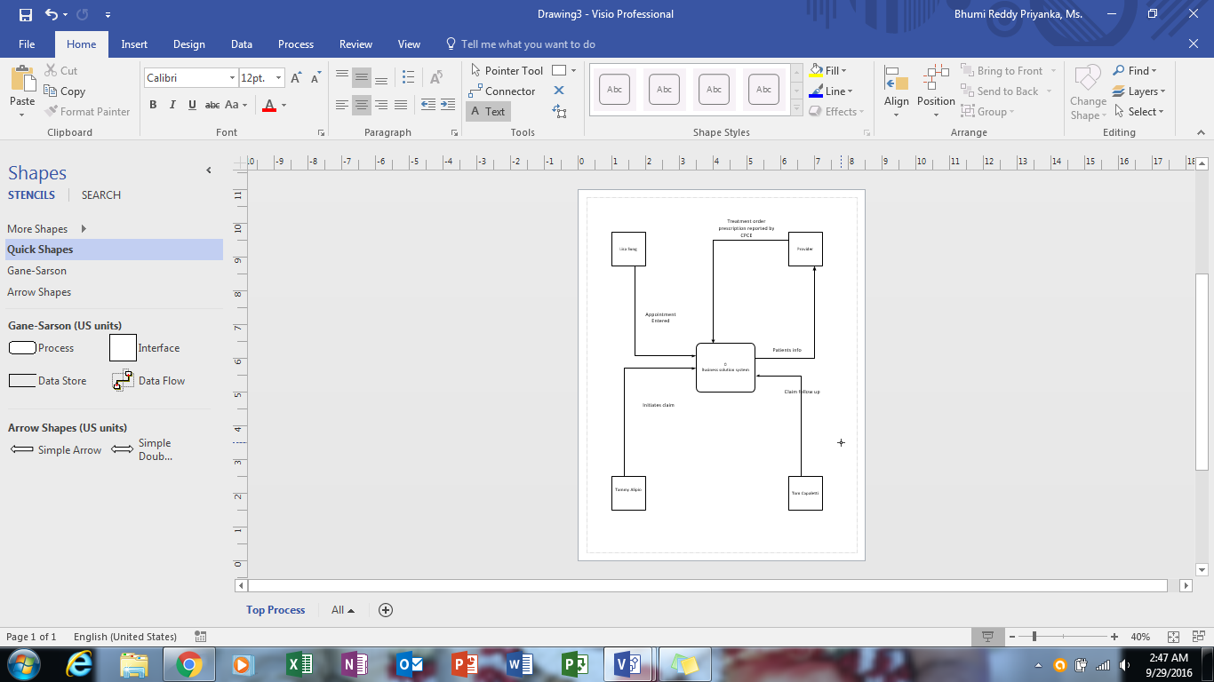

The business solution system operates all the functions of patients and insurance company. Lisa sung will take care of patient’s entry record like appointments, information which is stored in business solution system. The doctor sends information to business solution system. Tammy Alipio will initiates the insurance claims and Tom capaletti will follow up the insurances.

**Human Resources Module**

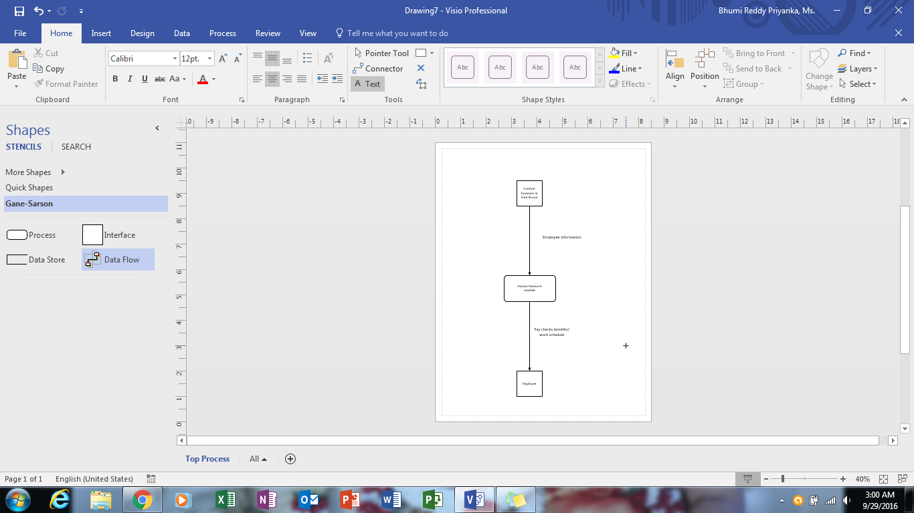

Corinne summers and Fred Brown will look after Human resource modules. Here they upload employee information to HR module and will send paychecks and work schedule to the employees.

**Classical Design Support System process**

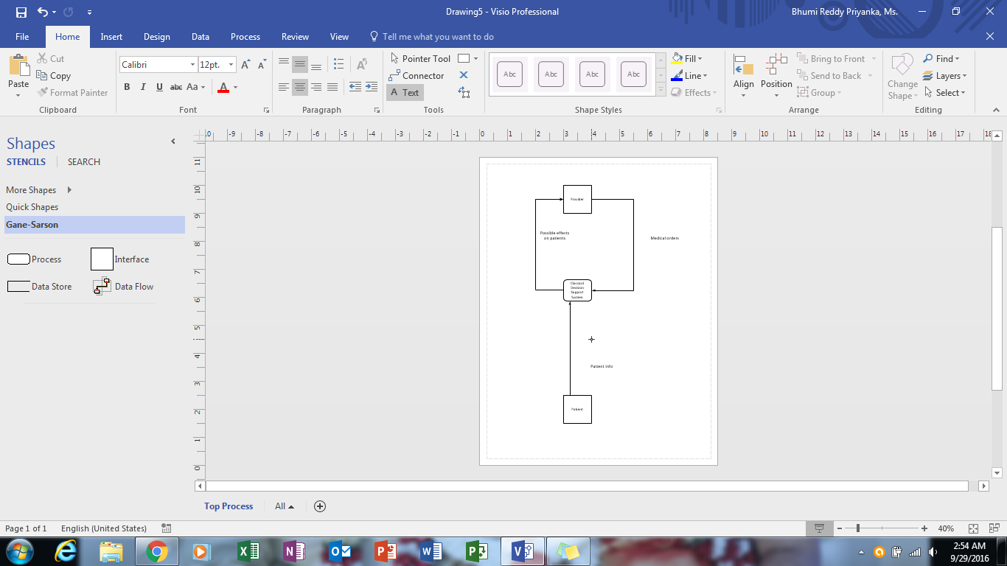

Classical Decision support system will look after the patient prescription. The CDSS process will have the patient information. Provider will send medical order to the CDSS module and it will send possible effects on patients.

**DATA FLOW DIAGRAM**

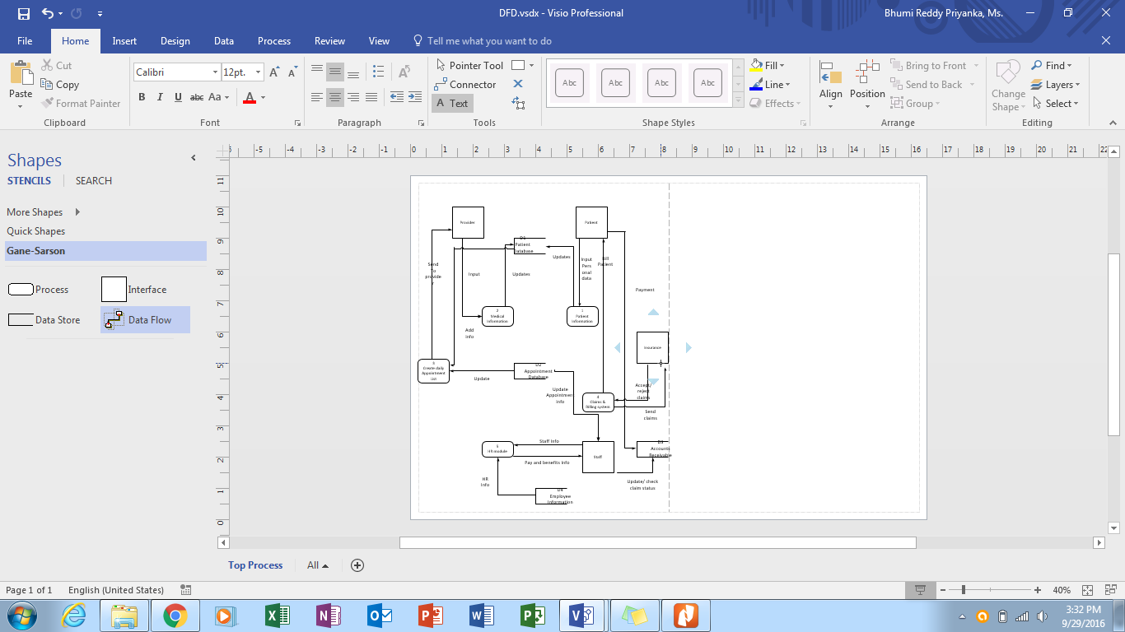

The Data flow diagram consists of all databases, process, and clients. In this data flow diagram, they have Patient database, Appointment database, Accounts Receivable, Employee information.

The patient database consists of all medical information of provider, Patients information, and also manage daily appointment list. Appointment database send all information to Appointment list. It also consists of all staff information. Claims and billing system will look after all billing and claiming issues.

**DATA DICTIONARY**

Data dictionary is a store house of systems data. Data store and data flow are followed by data structures which indeed composed of data elements. In this system the data stores and data flow are present.

Data stores

D1: Patient database

It consists of all information of each and every patient and their medical information. The staff and doctors utilize this database to know about the patient who ever comes to them. It includes all contact information, medical history, future appointments, etc.

D2: Appointment database

It contains of upcoming appointments of patients with dates and time. It takes information from patients about their availability and matches with doctor’s availability and make the appointments.

D3: Accounts receivable

This store consists of all insurance information of each patient. It also consists of payment information of patients. This store looks after the insurance bills, i.e. it claims to insurance and follow up, and get acceptance / reject of insurance and generating bills of patients to send to them.

D4: Employee information

It contains all information of staff and doctors. The pay checks, pay roll and taxes are taken care by this store.

Data flow

The data flow is an entity in data dictionary. It describes how the data flows in the data diagram. Here are some data flows used in this system:

Personal information input

Updating personal information

Giving Input

Send the documents to provider

Patient bill

Payment of patient

Update the appointment information

Send claim to insurance

Follow up the insurance

Accept/ reject insurance

Details of staff

Payroll and benefits information

Update/check claim status

Human resource information

**OBJECT MODELLING**

Object Modelling describes a software system with objects and classes. It defines the interactions between different models.

Steps involved in the object modelling:

1. Identifying the classes
2. Identifying the attributes and methods
3. Identifying the operations
4. Identifying the interactions between the classes.

https://lh6.googleusercontent.com/YBmTV9BH4Rh6vZNqsFXGB5a5kVofiN2KThyyjLZRsXJBzKdi7_KHCfa36enOSpcLu8Wg2Dk8josBlG_NN-qiObfErjQJwznlYpkl2x8HE8LKA8-UjvMifWH3ZFolwEkzXy2liGIdf-apvJlI7Q

**USE CASE DIAGRAMS**

**Appointment Scheduling**

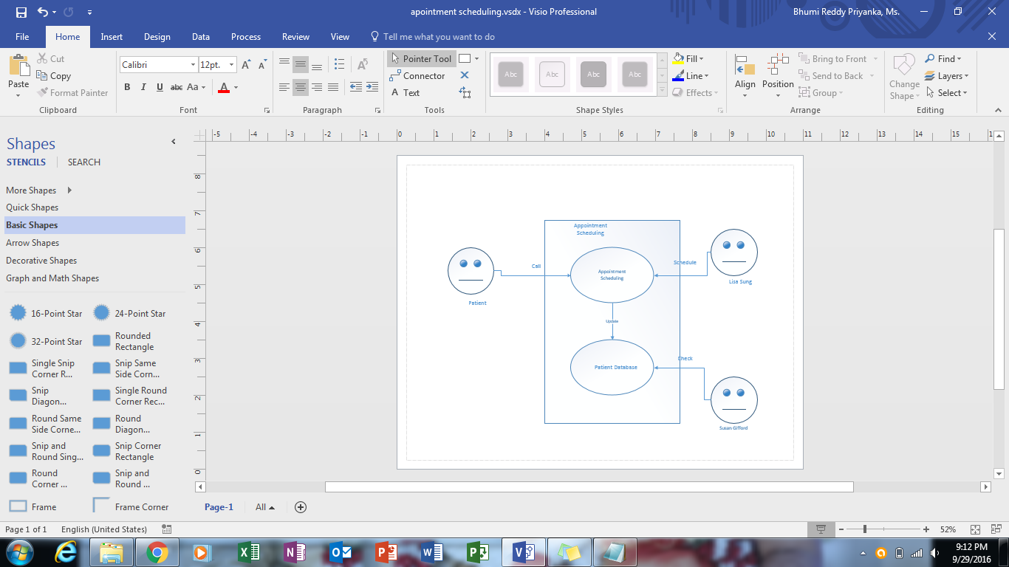

In this appointment scheduling the patient will call and Lisa sung is in charge for this appointment scheduling. Susan Gifford will check patient database and finalize the appointment.

**EMR Scheduling**

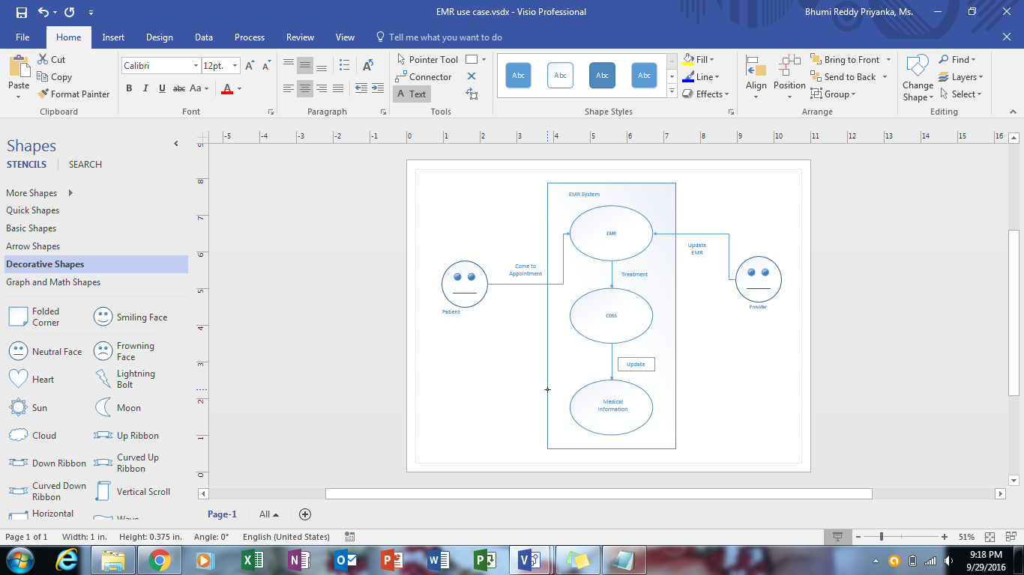

When patient visit the hospital doctor update EMR about patient status and EMR will send the treatment process to CDSS and update the information to medical information.

**Billing and Claiming Systems**

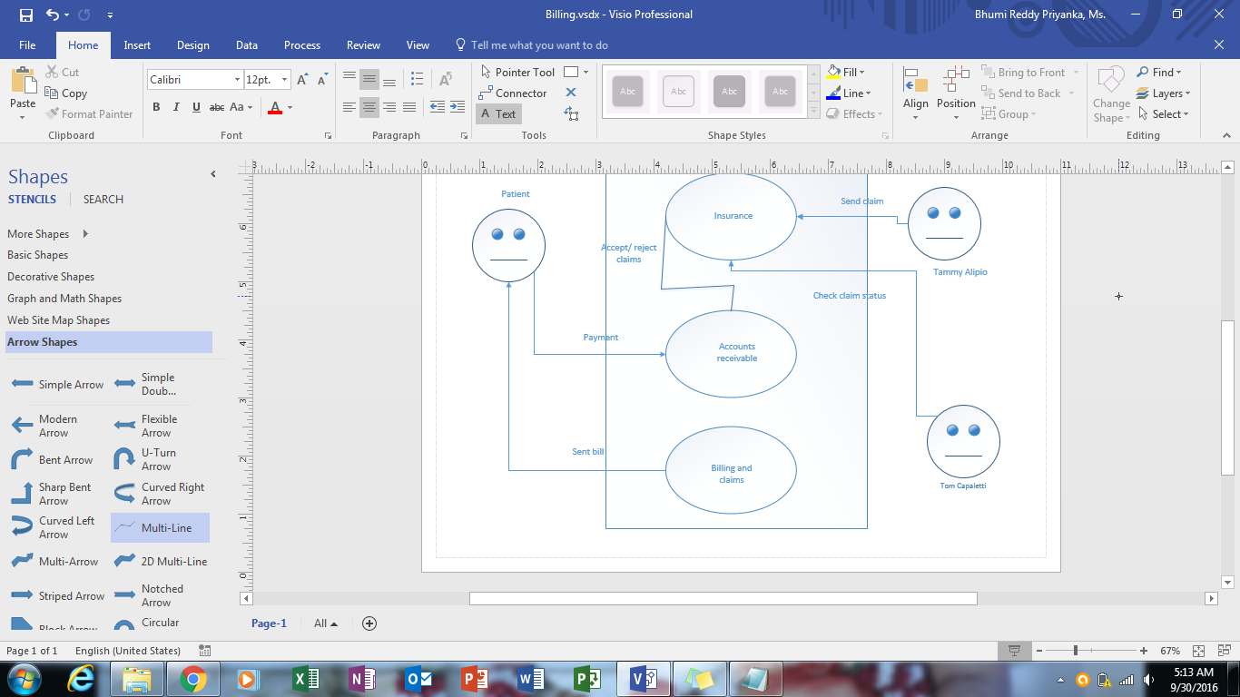

Tammy Alipio will claim insurance for patient’s bill, and Tom capaletti will check claim status and follow up the claim. Insurance will send the information of whether it accepts or rejects to accounts receivable, then patient will make payment and claim and billing process will sent over all bill to the patient.

**Human Resources Module**

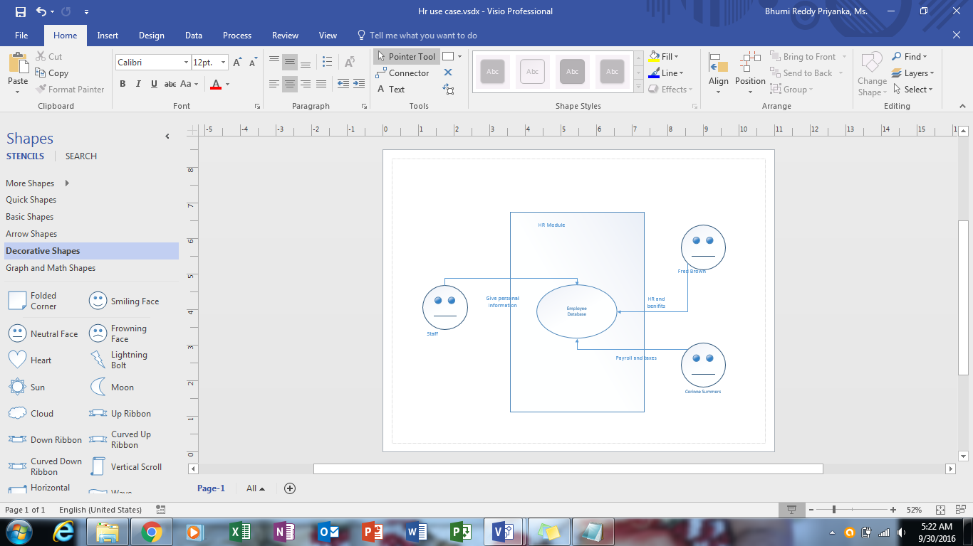

All employees will store personal information in employee database. Fred brown is in charge of HR and benefits and look after this personal info and carriane summers will update pay checks and taxes of employees.

**SYSTEM DESIGN SPECIFICATION**

Being the project manager, I take the responsibility of analyzing the current system and provide the team with alternatives of betterment. In this process, the team together has discussed through various scenarios in order to make a right decision about the system that fits perfect to the situation. The team members and I had a lots of detailed walk throughs in understanding what exactly are the requirements we are supposed to be holding on to, with the help of various basic techniques of system analysis. The final solution that we adopted is in-house development as the cost estimation of implementing the process was $19,300. The new system developed is aimed at removing the over time for six hours along with joining of additional resources into the project development. It also ensures that the data integrity is maintained along with the convenience of using is high for all the stakeholders. At this time, the development of the product has been through to the end according to the 12-week plan suggested by us earlier. In order to begin with the implementation phase, the employees are to be trained for 10 hours in regard with the usage of new system which might also include our additional support in the operation for as long as three months. The previous computer knowledge of an employee can bring some complications and thus require the extra assistance for the individual employees to help gain the highest system efficiency.

We have provided all the necessary documentation about the system. The corresponding members may ask any questions if you find anything unclear and feel there is a need to discuss. Although, the documents that have been provided, we think are self-explanatory.

Once, we have established the software requirements, it brings us to the hardware specifications needed for the project to be implemented. The hardware or the infrastructure can be installed within the building on weekends so that the work schedule is not disturbed on weekdays. Upon successful installation of the infrastructure, all the employees should use the initial login credentials in order to be able to use the system. At a later stage, they shall have the option of changing the password as they need. This new system expansion might introduce some restrictions to the data storage capacity and we three as a team shall be there for our team members to deal with all the unknown issues that might arise in the final installment of the product. As we proceed further, the issues might begin to hit the high rise during the first three months of the implementation and we will be there all along the course.

The process where employees’ or all the data records are stored in data base will require extra effort and co-operation from the staff to setup the perfect environment ready to use. All that said, this is required only if it wasn’t already included on the development plan. In case that this phase is required, then there might be some days that the clinic has to be shut so that all the required modifications are made without any irregularities.

The requirements for the training have been scheduled for two days in a conference room because it would not be long before the implementation phase begins. Also, this training shall help to discover any unknown problems due to the new system because a mock implementation of the system is necessary to help the employees and other staff understand what type of system they shall be working later on. A small session about the initial setup process during the training will help avoid a time loss that can be caused due to repetition at later stages. Since all the work is on schedule, the cost estimation also remains the same. The cost estimated also involves the costs for conference room booked for the training and the physical contractor work required. The contractor might have to drill into the walls under desk and to estimate the gauge of the work we will require some days with no one in the building/clinic.

We as a team would thank all the staff for providing this opportunity to work. It is a delightful three months to work and should you require any assistance in the future, any of the team members can just email at our contact us email address or just call at our work number (Rosenblatt, 2014).

**DATA DESIGN**

Structured development should be more accurate as the system is pretty much straight forward. Considering the designing of interfaces, the agile approach towards it, should be a right fit. The agile approach will provide the users with a benefit of a direct interaction with the system.

In order to finish the business support system as with more accuracy, using the tool right for the specific to the requirement is very important. Thus implies the usage of various tools in the task. The first tool to be used is for the creation of entity relationship diagram which explains the complete data interaction of the system in a graphic representation. A logical representation using the flow charts should help the developers in moving forward to generating the pseudocode (logic) for the entire process. Following by the flow chart, comes around the creation of decision trees and tables to help with cross checking the logic considered in the previous diagram and make the necessary conditions if at all.

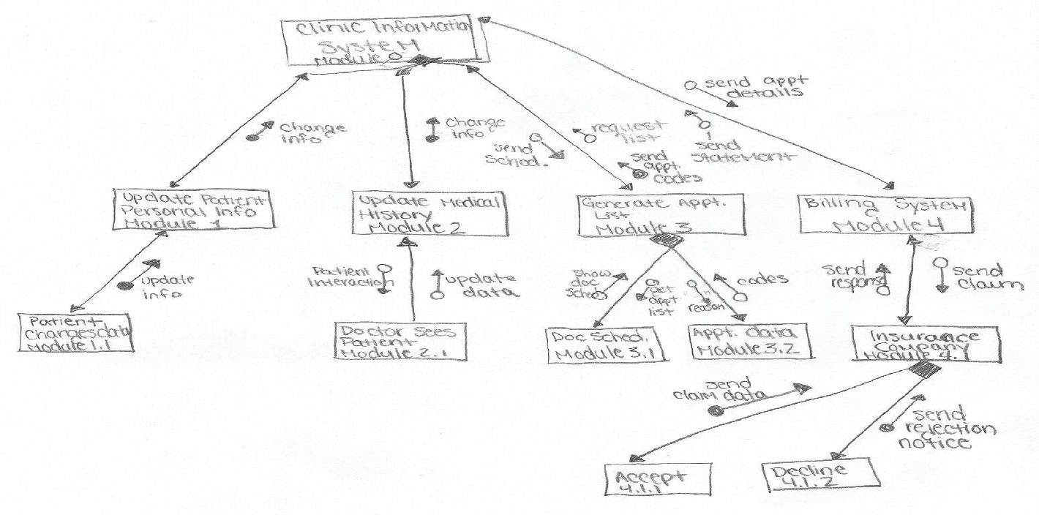

Once the development process has been completed successfully, we would recommend the team to perform the unit testing in order to ensure the efficiency and accuracy of the overall software system compared to the previous and the existing system. In a business, the integration of new system is as much important as developing the new systems’. Because a minute error in the integration of the system to other modules can lead to a failure in the whole system. Hence, to make sure that the system that our team has developed, testing the billing department system as a precautionary measure is advisable. The integration testing is done using the live data using the parallel change over method in order to the switch over the system. A sample of the test data with some errors has been provided below.

* Accurate and according to the required parameters.
* Discrepancy in the date of birth.
* Difference in the value entered in Heartrate.
* Name field error.
* Mistake in the blood pressure field
* Miscalculated value for How much (per day) field
* A misprint in the Oxygen Saturation% field.

Receptionist Training will include:

* Scheduling an Appointment
* Modifications with patient’s personal information.
* Viewing of calendar for appointments, paystubs, email
* IN/OUT timings of patient
* Work schedule

Training for Nurse includes:

* Scheduling an Appointment
* Modifications with patient’s medical history and personal information.
* Viewing of calendar for appointments, paystubs, email
* Work schedule

Training for Doctor involves:

* Scheduling an Appointment
* Modifications with patient’s personal information and medical history.
* Viewing of calendar for appointments, paystubs, email
* Work schedule
* Prescribing the medication to the patient.
* Sending the scripts to pharmacy.

Training for the billing department employees include:

* Claim handling
* Management of patient’s personal data.
* Viewing of calendar for appointments, paystubs, email
* View the response from the insurance team about claims
* Work schedule
* Management of billing and insurance data.
* Sending claims to insurance department
* Provide the final invoice to the patient

**USER INTERFACE DESIGN**

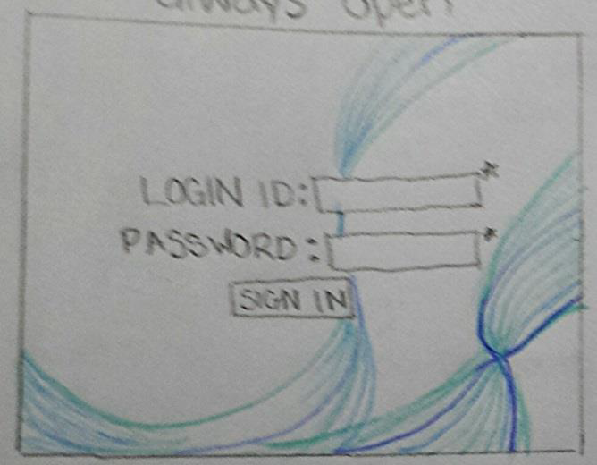

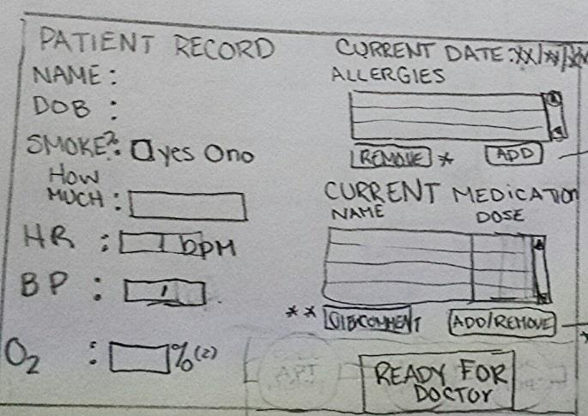

We chose to keep the login screen very much simple while taking care of the security concerns with compulsory and dedicated set of login.

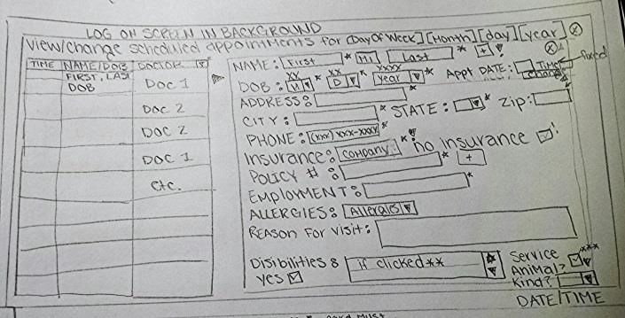

The adjacent picture explains how the interaction of patient with the system would be and the adjacent screen can be used to enter and store the personal data records. All the fields in the picture are made mandatory by putting some validation check in the code to maintain the integrity of the data.

While the adjacent picture to the right, is the screen much utilized and needed by the receptionists, doctors and nurses will also be able to use a similar feature of viewing and editing the appointments with only options that they use far better than the sending a voice note to the recipient. This is will help remove the clumsiness in the web design by removing the unwanted components.

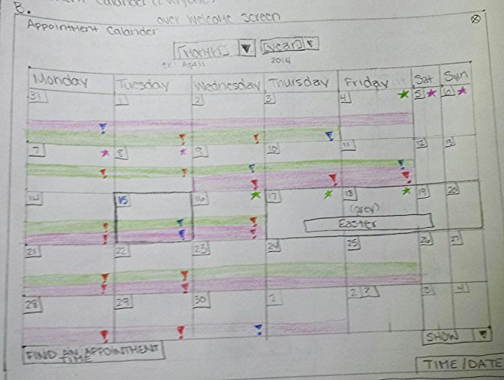

This figure describes exactly what we were referring to achieve in the previous step. The calendar is available to everyone including doctors and nurses, providing the details of appointment scheduled for the month and also when are the specific time periods that the doctor is bust treating the patient's ailment. In the upgrade, we also plan to have the appointment calendar specific to the patient.

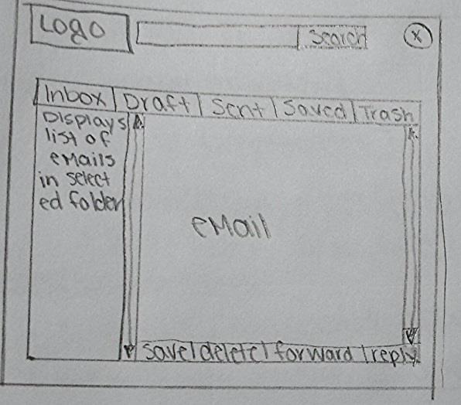

The New century wellness group Inc. has incorporated with an absolutely efficient feature for communication with the doctors and staff using the email option. This in built messaging will help the users to keep track of all the important emails and set reminders so that they do not miss any appointments.

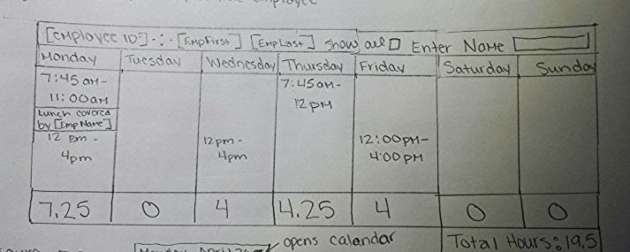

The user/employee can view the work schedule for that week by opening the corresponding link and navigate through the different weeks to see that particular schedule. Also, the future weeks for which the user has not yet worked, will be designed as unselect able.

**FEASIBILITY ANALYSIS**

I sincerely thank all of you for taking the interest in contacting us with the concerns or queries you have. There are many issues to be dealt with. For example, slow response time, continuing maintenance and security issues. We shall discuss through all the issues in an order.

**Slow Response Time**

Now that we have understood the team has many issues to be dealt with and the first issue which is of highest concern is having a slow response time, we as a group have put forward a way to explain this situation. The reasons behind the situation being primary concern can be explained better when dealt in three parts.

* Response Time: The response time is calculated by totaling the duration from the request being sent and till the response is received from performing the system activities.
* Bandwidth: Bandwidth can be explained as the capacity of the system to transfer a certain data size at any particular point of time.
* Throughput: The performance of the system under certain situations in a real time environment.

**Ongoing Maintenance**

In the next step of clarifying and resolving the concerns, we shall move forward to discuss about the type of maintenance that is actually required for our system and the other possible maintenance activities that can be implemented. So in order to finalize on the maintenance type, we will give you all the clear idea of how the different types of maintenance can be used.

* A maintenance method where the errors in an operational system are discovered and corrected is called corrective maintenance. We have received some inquiries that the administration department has been experiencing some slowness in the response time with different intervals. According to my observation, it was as result of high server volume. The delay in the course of work load has been the bi product of this situation even then it was not given the recommended priority.

The areas where the corrective maintenance can be of high use is when there are errors seen during the course of programming the modules and that they are to be carried out only for the situations leading to a halt in the daily activities scheduled at a normal rate. Although, it would seem angel like to have a final product only in the initial turn out, there is much to the possibility of missing out the minute errors or maybe even little bigger ones within the code even for a diligent testing due to complexity of the program. Sometimes, a particular error may be only identified after the system changeover has been taken place.

The priority level category for the corrective maintenance is at 1. The issues that are dealt with this type of maintenance should be really of a great impact for IT operations that are supposedly require the immediate utmost attention are taken care by providing a patch or a work around and then making sure that these solutions are implemented as soon as possible.

* Adaptive maintenance comes into picture when there are requirements of enhancements into the system. For instance, a business is supposed to grow very often and that new requirements for changing the existing UI design options might well be in practice. One more instance which can be of a high business orderly effective could be integrating the system with web interface in order to allow the users or the customers to view their medical records, appointment history, book an appointment for a later date within the luxury of sitting house.

The adaptive maintenance is categorized in the priority level 2 because it has a little impact on the IT operations along with the security events or any other activities involving the business actions. Although, it is clear that these type of services requires a pure and fine attention towards them, the system analyst can take time to find a perfect solution for the issue while the business operations would not have to halt and proceed into further operations. Once, the solution is ready, they are patched as and where requirement is available and consecutively implemented just before the next cycle of upgradation begins.

* The third type of category in maintenance is called perfective maintenance which involves a complete transformation of operational system for a better efficiency, reliability and maintainability. We have received a few change requests for reporting tools and forms that are extracted in the existing system of New Century Wellness. Along with the requests received we have found that there can be one more functionality added to this existing system that can help or assistant customers much more efficiently There have been continuous requests to make the changes effective as soon as possible.

The tasks requiring such type of maintenance under a priority level of three. And this is because they have rather negligible effect on the ongoing IT operations and security or business activity. These activities or upgradations are usually prolonged until there is final big change requirement necessary to be done and taken place as one software update.

* In the event of occurrence of an error has a high probability, then the preventive maintenance is the first choice. The initiative is taken by the IT department for this type of maintenance. These updates are proportional to the user satisfaction and indirectly related to the performance downtime. The huge volumes of data transmission can cause a failure in the hardware equipment and prone to hazards and thus require a preventive maintenance activity to be undertaken very frequently. This can be an alternate solution to the slow response time problem. There have been many concerns brought up to us about the security of system being a little compromised and preventive measures can come to the rescue. The highest level of priority is for the preventive maintenance. All the issues must be of high important since they have a great impact on business operations and IT department activity. It is unfortunate that this type of maintenance activities are not given the degree of importance that it is entitled to, unless they are crossing borders with the corrective maintenance activities.

**Security Issues**

The best way of securing the data is by using the WPA2 mechanism. The WP2 mechanism will be able to secure the data with higher precision. As the team has approached us for a solution, we found that providing the security is at the highest for the medical records since they not only contain the medical information but also the personal information such as the SSN, driving license and insurance card details etc. The security can have provided at different levels of authorization.

A firewall is another way of securing the important information over network. Of all the options available, implementing the multilayer gateway sounds better. The personalized password security for the system users is also at the next high priority. The system should ensure to prompt the user to change their passwords every three months and that the new password does not match with the old few passwords. Also, putting certain limitations over the password sensitivity with allowing only certain characters and numerical along with suggestions of how to create a strong password can help with the high sensitivity of the passwords.

To ensure the security is not compromised, we as a team advise the users of the server room to lock the system when not in use. And that the computer systems used by the team members are locked securely at the end of the day while leaving for the day.

**PROJECT PLAN**

**Work Breakdown Structure**

The Work Breakdown Structure (WBS) is a progressive deterioration of the venture targets into deliverable-arranged errands that are executed by the task group to perform the general undertaking objectives (Piscopo, 2012). An endeavor, for example, this is very vast and will take some an opportunity to finish. The WBS isolates the undertaking into littler, more sensible segments to ensure my group and I can keep up control and finish the errands in a convenient and composed way. Starting with more elevated amount assignments and moving descending, the errands begin off wide and slowly turn out to be more itemized. I composed the WBS with the goal that you can take after our advancement and see when assignments will be finished. The following is my propose WBS for your EMR framework. My group and I will do our best to adhere to this calendar with the goal that you know about everything that is going on, and if issues emerge I will quickly alarm you when necessary.

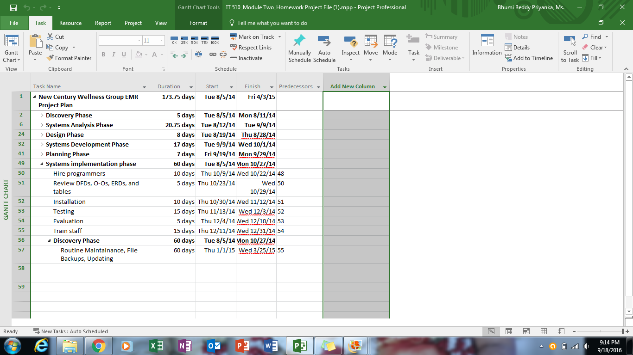

You will see I have recorded the past periods of this undertaking, Discovery, Systems Analysis, Design and Systems Development alongside their terms. I have made undertaking records for each of those stages, but since we are worried with my execution of this framework, I exited those rundowns caved in. I would be more than willing to give that data upon solicitation. In taking a gander at this WBS, you will see that every undertaking has a WBS number. That number demonstrates when every undertaking can start. Our next undertaking is 1.6 Systems Implementation Phase. I am assessing that this will take around 60 days working all day. I have procured two software engineers, Celia Goldring and Bill Miller, to help me in this attempt. Together we will survey all organization reports you have as of now gave to me, introduce the equipment and programming, test the framework, assess it, and after that prepare the staff to utilize it. You can likewise see a section entitled Predecessors. These assignments can't begin until their forerunner undertakings are finished. For instance, errand 52 Installation can't start until its forerunner, undertaking number 51 Review DFDs, O-Os, ERDs, and the tables are finished. This ups keep focused and permits me to redesign New Century staff of our advancement.

**Project Monitoring and Control Plan**

As the system analyst for this undertaking, I am likewise going about as the venture administrator. I must ensure that this undertaking runs easily and that my customer, New Century Wellness Group, and my programming group, Celia Goldring and Bill Miller, are fulfilled. I need to begin by executing organized walk-throughs. An organized stroll through is an audit of a task colleague's work by different individuals from the group (Rosenblatt, Systems Analysis and Design, tenth Edition, 2014). The software engineers will audit each other's work and my arrangements, and I will survey their work also. Testing each other's codes and outlines will guarantee legitimate framework usage.

As the lead on this task, I must expect the unforeseen. Generally, as in life, at times ventures have issues. By mapping out my System Development Life Cycle (SDLC) in my WBS, I can start to suspect potential issues. This sort of ground breaking can help me minimize difficulties and remain focused and on spending plan. I anticipate taking after a Program Evaluation Review Technique, or PERT, outline to help my group keep focused. The PERT outline will delineate what should be done to guarantee the new framework is actualized legitimately (Rosenblatt, Systems Design and Analysis, tenth Edition, 2014). Keeping this diagram will likewise permit me to keep New Century's accomplices and staff informed of our advancement. Saucy graphs show every single essential assignment, errand designs and their spans; it will likewise help me know whether and when basic components and points of reference are not being met. I will likewise make certain to meet with my group regularly to evaluate their advancement. Through general task status gatherings with Bill and Celia, I will have the capacity to gather, check, sort out and assess data about the undertaking.

I will have the capacity to hand-off any important data to Dr. Jones and the New Century staff. These gatherings will likewise permit my group and I to conceptualize answers for any issues that emerge. Should the New Century staff incline toward archived progress, these gatherings will permit me to make reports enumerating precisely where we are in the usage procedure and answer any inquiries they may have. I additionally anticipate meeting with Dr. Jones all through execution to answer any inquiries he and accomplices may have. I need to ensure he feels great with the advancement we are making and the frameworks we are working for his practice. My basic way, or the grouping of stages deciding the base time required for an operation, particularly when broke down on a PC for a substantial association can be seen beneath in my Timeline segment.

**Timeline**

I evaluate implantation will take 12 weeks or 60 working days. To display this I have incorporated a Gantt outline on the following page for your benefit. It is an even bar diagram illustrative of the frameworks usage assignments (Rosenblatt, Systems Design and Analysis, tenth Edition, 2014). The graph likewise incorporates a particular undertaking list from my past WBS and the term of every errand. You will likewise see that the segment of the bar diagram by execution undertakings is red. These are basic errands. These assignments are critical to the task's auspicious fruition.

As should be obvious, my group and I will handle those basic undertakings. The diagram likewise gives a time span for when we will be done which I am assessing to be this coming February.

Next I have incorporated a Resource Sheet and Cost sheet itemizing all gatherings required in this undertaking and expenses connected with this task.

**Timeline**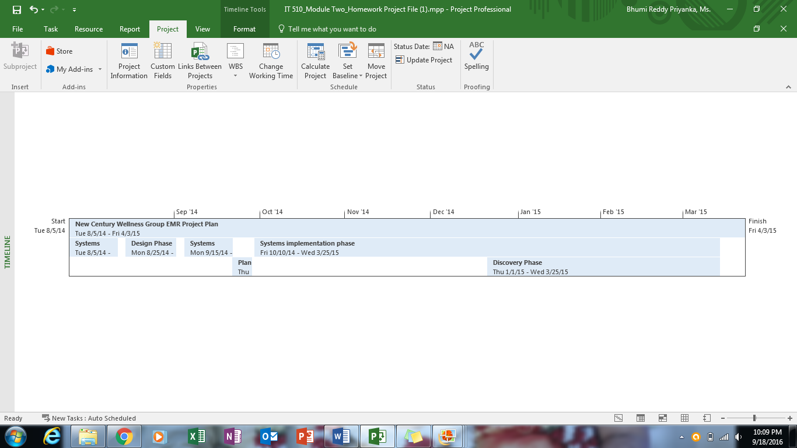

**Resource Sheet**

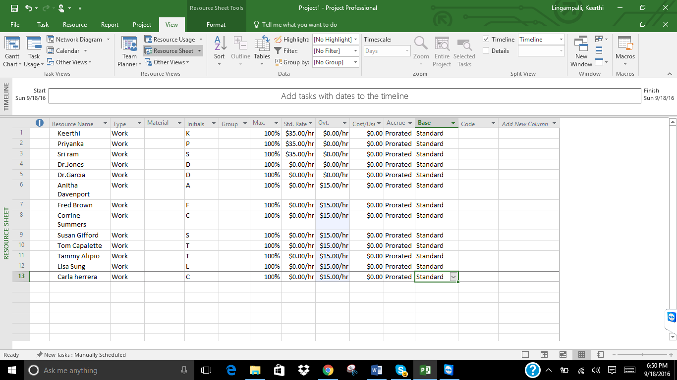

**Cost Sheet**

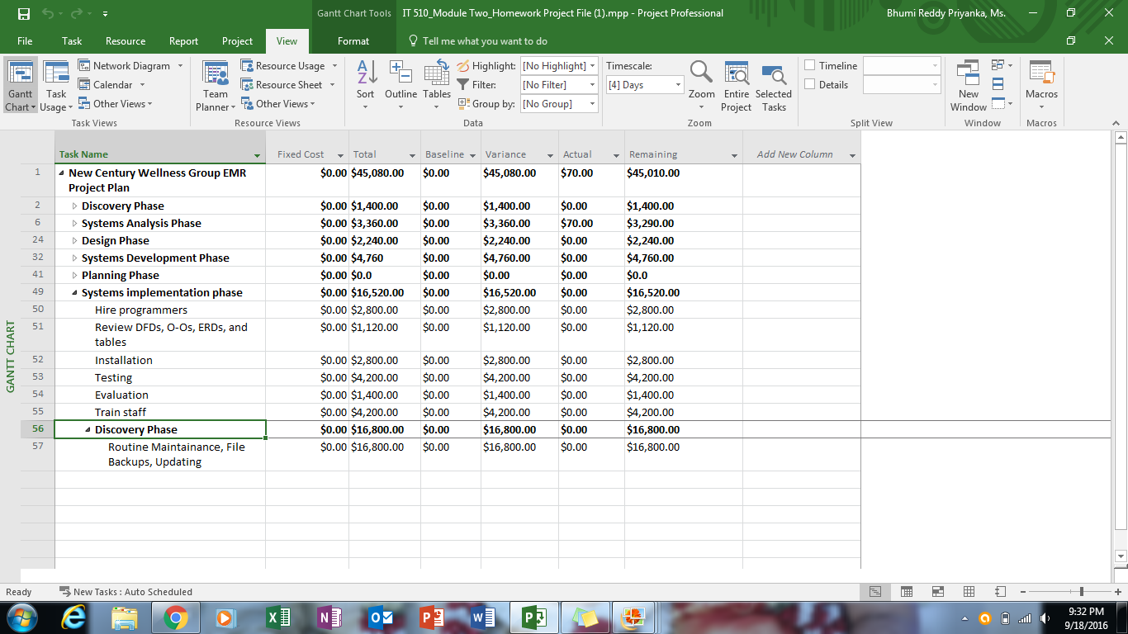

New Century Wellness Group is a flourishing medicinal center. It is my conviction that with the assistance of my framework, New Century could be significantly more fruitful. My framework will help the workplace run all the more proficiently and taken a portion of the weight off of the staff so that their principle concern can be the patients. Much obliged to you for your time and thought. On the off chance that you ought to have any further inquiries kindly don't dither to reach me.

Reference

Piscopo, M. (2012, May 6). Creating a Work Breakdown Structure with Microsoft Project. Retrieved June 16, 2016, from Project Smart: [https://www.projectsmart.co.uk/creating-a-work- breakdown-structure-with-microsoft-project.php](https://www.projectsmart.co.uk/creating-a-work-%20breakdown-structure-with-microsoft-project.php)

Rosenblatt, H. J. (2014). *Systems analysis and design* (10th ed.). New York, NY, United States: Course Technology.